SLATE in Action Observation Discussion Guide

This guide helps Provisional Volunteers assess how SLATE is employed during each of their onboarding co-mentoring sessions. Provisional Volunteers, as well as newly active volunteers, should go through this guide with the mentors they observe and lead with, or their Coach to foster a meaningful dialogue to help them better understand and apply the SLATE methodology.
Note: When you lead the session during co-mentoring you are the “mentor” in this observation.
S  Stop and Suspend Judgment | - Was the purpose of the meeting clearly stated?  - How did the mentor demonstrate his or her focused attention to the client?  - In what ways did the mentor engage the client?  - How did the mentor suspend judgment while the client spoke?
L  Listen and Learn | - In what ways did the mentor exhibit active listening and ask questions to help the client think deeply?  - How was the mentor learning more about the client’s needs and objectives as time went along?
A  Assess and Analyze | - How did the mentor use exploratory dialogue including questions to help the client assess the issues?  - In what ways did the mentor help the client analyze the issues logically and methodically so that he or she could determine the best course of action?
T  Test Ideas and Teach with Tools | - How did the mentor provide opportunities for testing to discover the best idea or to refine an idea?  - What types of tools did the mentor suggest to expand the client’s knowledge?  - In what ways did the mentor help the client learn more about his or her idea as the session went along?
E  Expectations Setting and Encourage the Dream | - How did the mentor end the session?  - Were clear expectations and appropriate next steps determined?  - In what ways did the mentor provide encouragement for entrepreneurship?  - Did the mentor talk specifically about a next meeting?

CONSIDER:
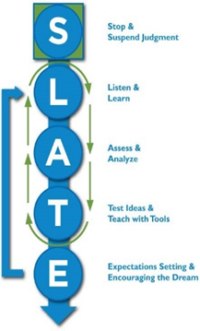
- Are there any areas of the SLATE methodology where you will have particular strengths?
- Are there any elements of SLATE that might be areas of weakness for you? If so, how can you improve on these areas?
- How will you ensure that you are applying the SLATE methodology throughout your mentoring?
- SLATE is the mentoring process. What about the techical and business related content of mentoring?
  - Do you know how to find local and national SCORE mentors who can help you with this client in areas you are not expert?
  - Do you know how to find SCORE and other resources that you can use and/or refer the client to?
  - Are there areas that you can self-develop with workshops and other training resources such as those on the SCORE.org website and in the Volunteer Support Center?
Date:
Mentor Name:
Provisional Volunteer Name:
Notes:

